Pokhara University

Level: Bachelor | Semester – Spring | Year : 2005
Programme: BE |  | Full Marks : 100
Course: Mathematical Foundation of Computer Science |  | Time : 3hrs.

Candidates are required to give their answers in their own words as far as practicable.
The figures in the margin indicate full marks.

Attempt all the questions.

1. | - Show that the hypothesis "It is not sunny this afternoon and it is colder than yesterday". "We will go swimming only if it is sunny". "If we do not go swimming then we will take a canoe trip" and If we take a canoe trip, then we will be home by sunset" Lead to the conclusion "we will be home by sunset".  - Show by giving a proof by contradiction, that if 100 balls are placed in nine boxes, some box contains 12 or more balls. | 8  7
2. | a) Find by truth table, whether or not the following propositions are logically equivalent  b) Prove that for all integers 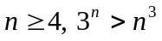  c) Consider the argument  All men are fallible  All Kings are men  Therefore, all kings are fallible. Verify the conclusion all kings are fallible. | 5  5  5
3. | a) Population of a city is 100 thousand at time t = 0 and 170 at time t = 1 and that the increase from time t-1 to time t is twice the increase from time t-2 to time t-1. Write a recurrence relation and initial condition that define the population at time t and then solve the recurrence relation.  b) Messages are transmitted over a communication channel using two signals. The transmittal of one signal requires 1μs and the transmittal of the other signal requires 2 μs. | 8  7
4. | - Apply Dijkstra's algorithm to the weighted graph shown below to determine all minimum distances from vertex 1 to all other vertices.  - Represent the following graph using the adjacency and incident matrices. Also find the square of adjacency matrix.  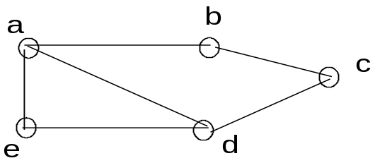 | 7  8
5. | - Is there a graph with degree sequence (1, 3, 3, 5, 6, 6)? Explain with mathematical reason.  - A farmer, a wolf and a cabbage are all on one side of a river and have to be transported to the other side. The farmer has boat in which he can carry at most one passenger at a time (where cabbage counts as a "passenger"). The goat cannot be left with the wolf, or the cabbage with the goat, unless the farmer is there too. Draw a digraph to show positions which can be reached legitimately and hence solve the problem. | 7  8
6. | a) Draw the transition diagram of the finite state automation (I, S, f, A σ₀), where I = {a, b, c}, S = {σ_{0,} σ_{1,} σ_{2,} σ₃}, A = {σ₀, σ₂}. Also characterize the strings accepted by the finite state automata. | 8
 | a | b | c
σ₀ | σ₁ | σ₀ | σ₂
σ₁ | σ₀ | σ₃ | σ₀
σ₂ | σ₃ | σ₂ | σ₀
σ₃ | σ₁ | σ₀ | σ₁

 | b) Design a finite state machine that performs serial addition | 7
7. | Write short notes on (Any two):  - Universal and existential quantifies  - Graph Isomorphism  - Types of grammar | 2×5

